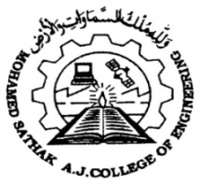
MOHAMED SATHAK AJ COLLEGE OF ENGINEERING
(Approved by All India Council for Technical Education,
New Delhi and affiliated to Anna University, Chennai)
Siruseri IT Park, Egattur, Chennai - 603 103

6.3.4 Average percentage of teachers undergoing online / face to face faculty Development programmes (FDP)

Sl.No | Description | Link of the Report
1 | Academic Year 2016-2017 | View file
2 | Academic Year 2017-2018 | View file
3 | Academic Year 2018-2019 | View file
4 | Academic Year 2019-2020 | View file
5 | Academic Year 2020-2021 | View file

