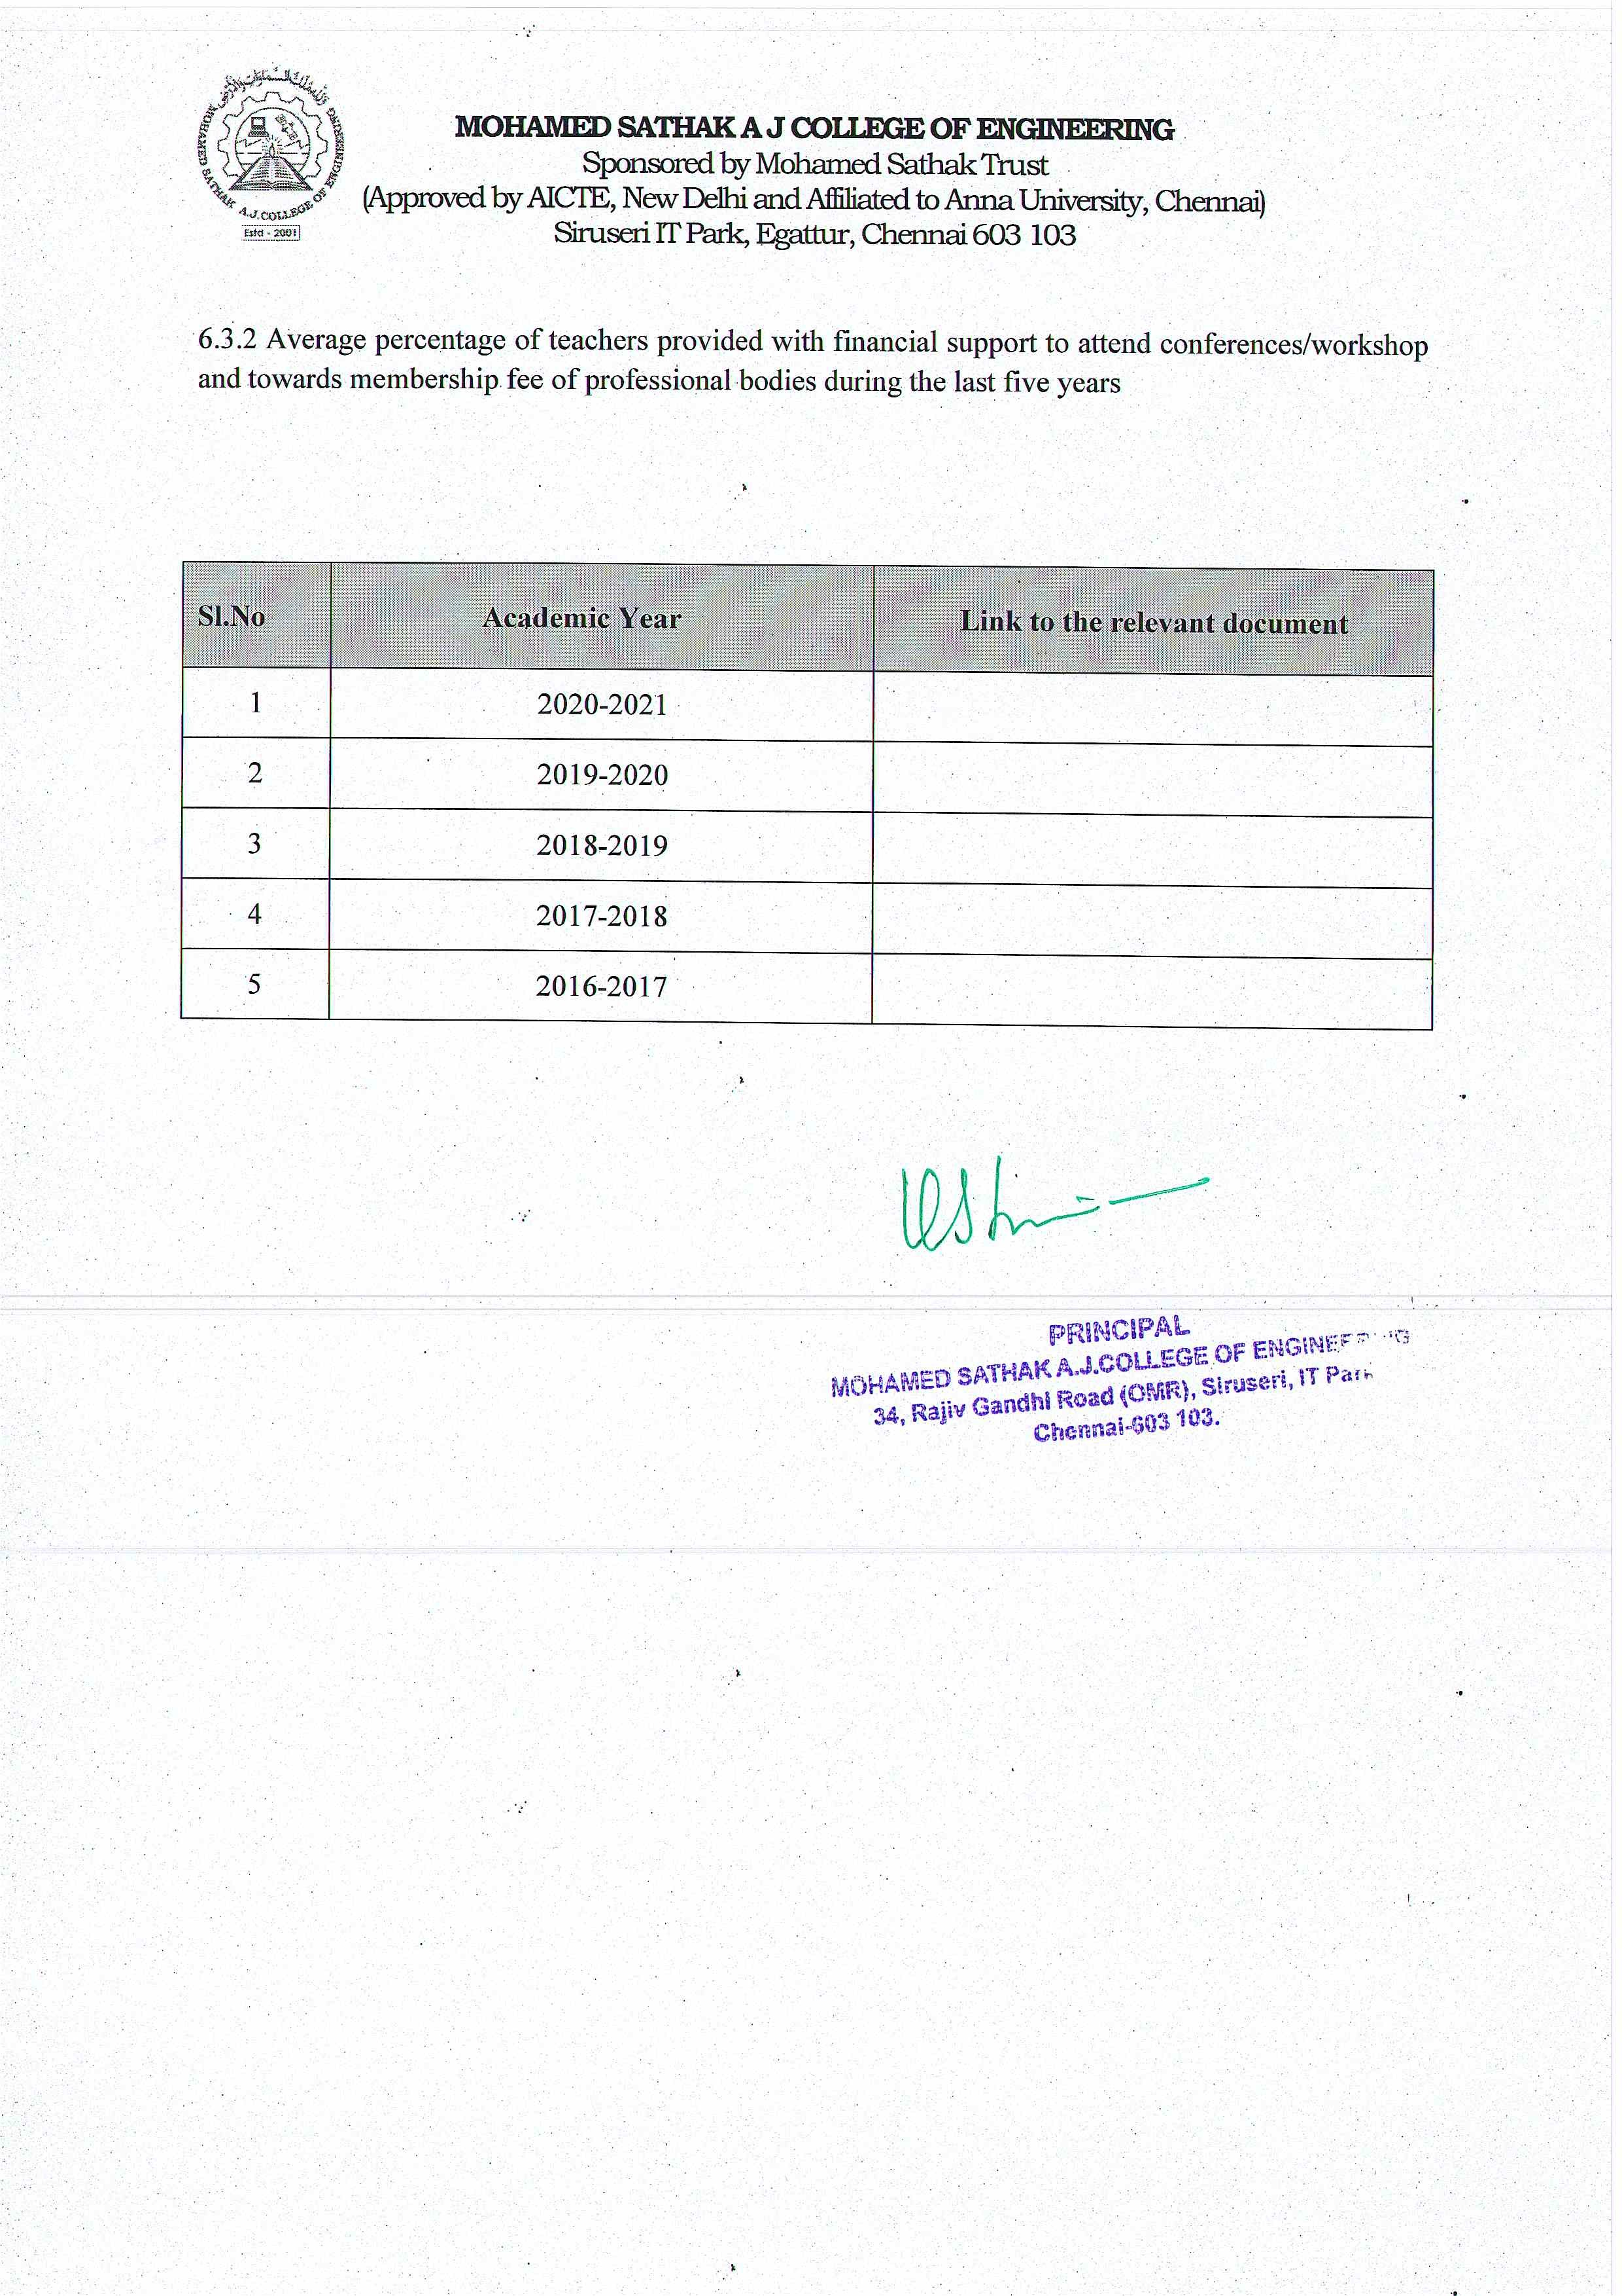

View File

View File

View File

View File

View File

