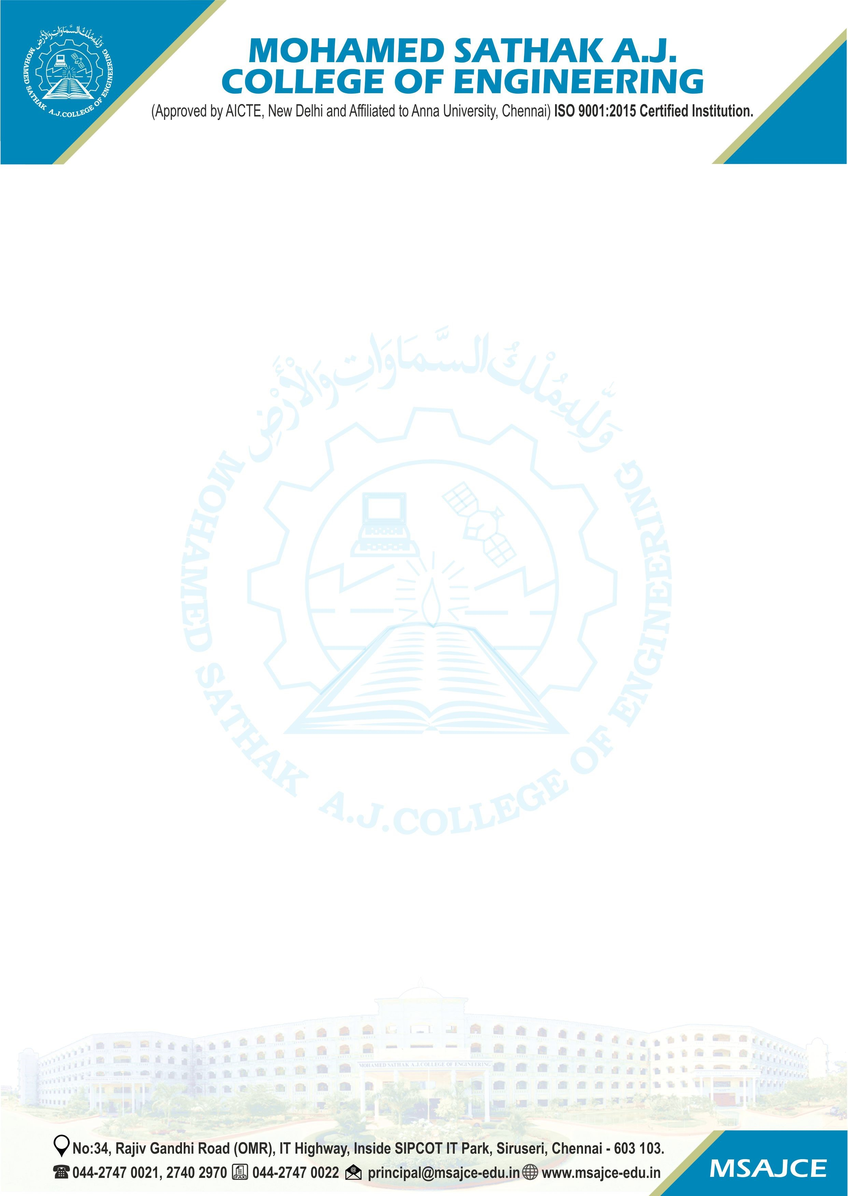

Metric | Particulars
1.3.3 | Percentage of students undertaking project work/field work/ internships (Data for the latest completed academic year).

1.3.3.1. Number of students undertaking project work/field work / internships

HEI Input | 221
DVV Suggested Input | 100
Change Input  (Optional) | 223

HEI Input:

DVV Clarification | HEI Responses
List of students undertaking the project | List of students undertaking the field projects / internship program-wise in the last completed academic year along with the details of title, place of work etc is provided.
work/field work/ internship during the
last completed academic year along
with the details of title, place of work
etc. to be certified by the Authorized
person,
The Internship completion certificate | Internship completion certificate / project work completion certificate from the organization where internship / project was completed along with the duration is provided.
from the organization where the
internship/ project was completed along with the duration of the same is to be provided.
Report of the field visit/sample | Report of the field work / sample photographs of the field work / permission letter only for field work from the competent authority is provided.
photographs of the field
visit/permission letter from the
competent authority only will be
considered. DVV has updated the data on pro-rata basis.

List of Documents uploaded:

S. No. | Particulars | Link
1. | Certificate from the Head of the institution | View File
2. | List of Students Undertaking Project Work/Field  Work/ Internships with details of Title and Place of Work | View File
3 | Project work completion certificate | View File
4 | Report of the Field Work | View File
5 | Revised Data Template | View File

