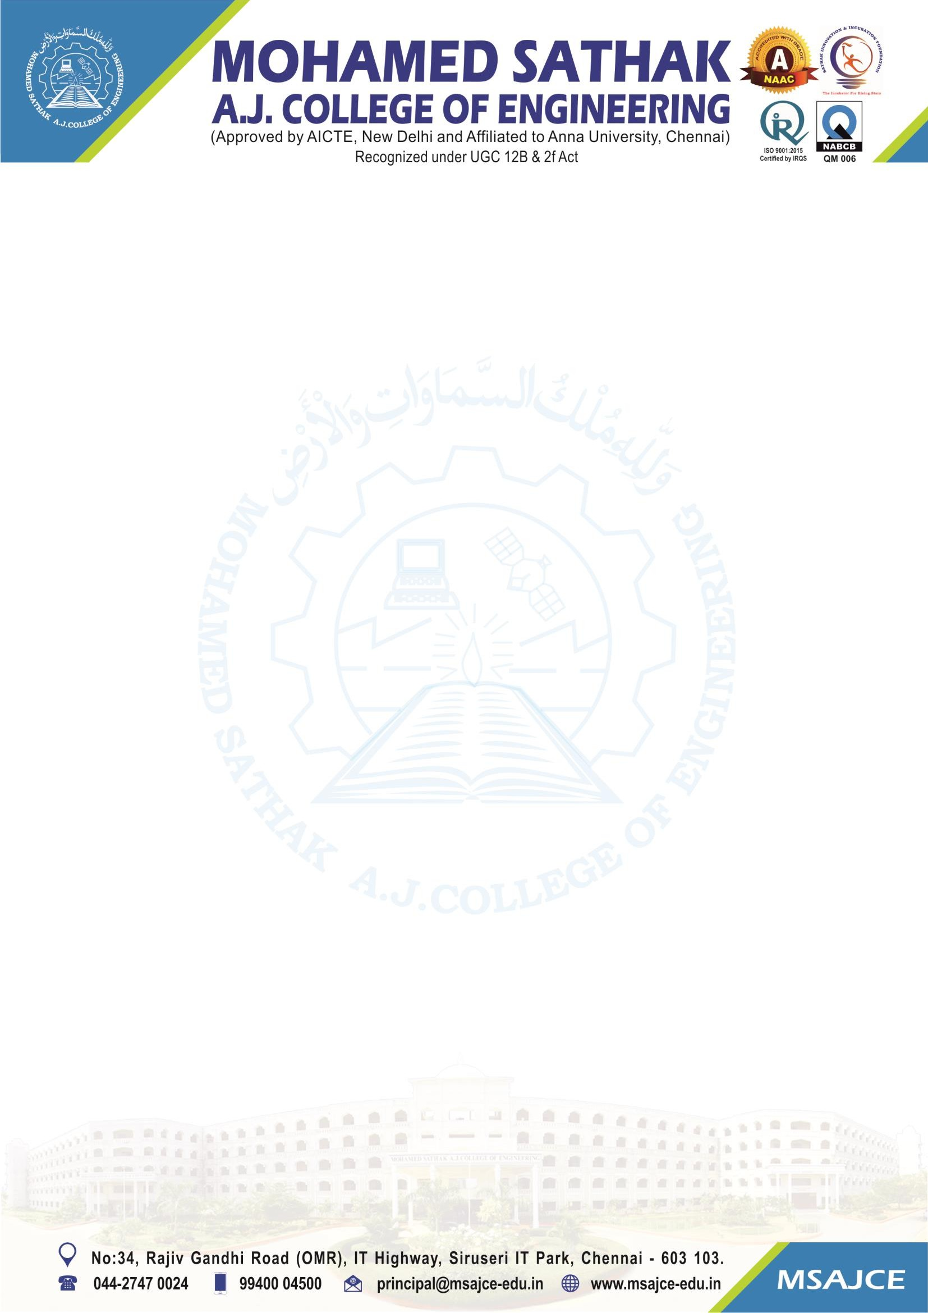
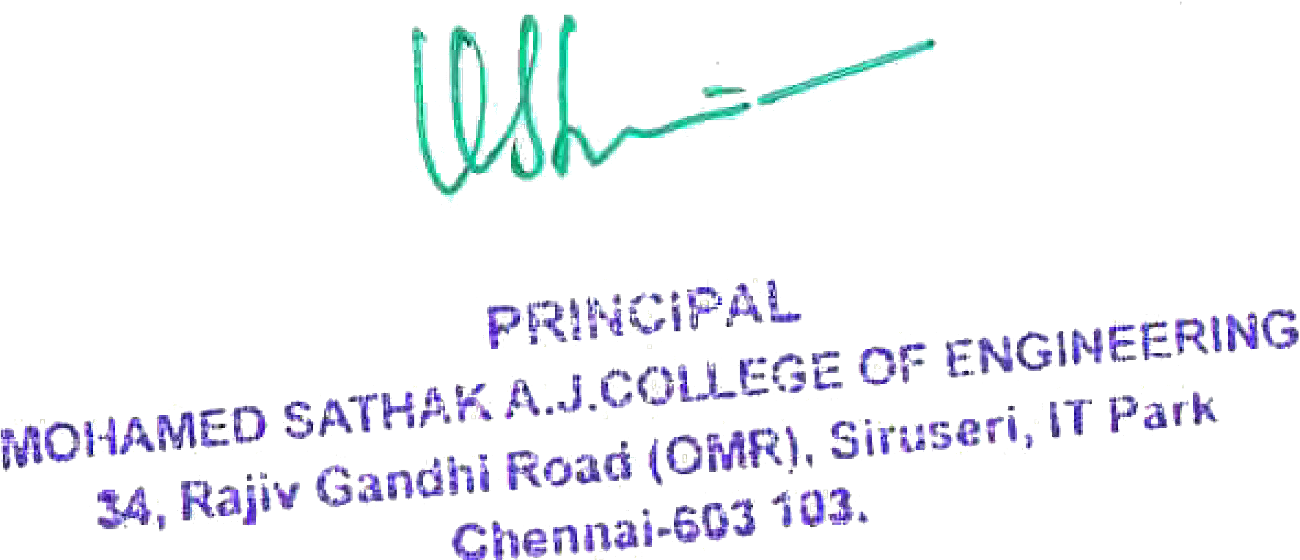

5.3.3: Number of sports and cultural events / competitions organized by the institution

Note: The supporting documents for this metric exceed the upload limit of 6 Mb. Hence the documents are made available in HEI website and links for the metric is given below.

Metric | Parameter | Link to Relevant Documents
5.3.3 | Number of sports and cultural events / competitions organized by the institution | View File

