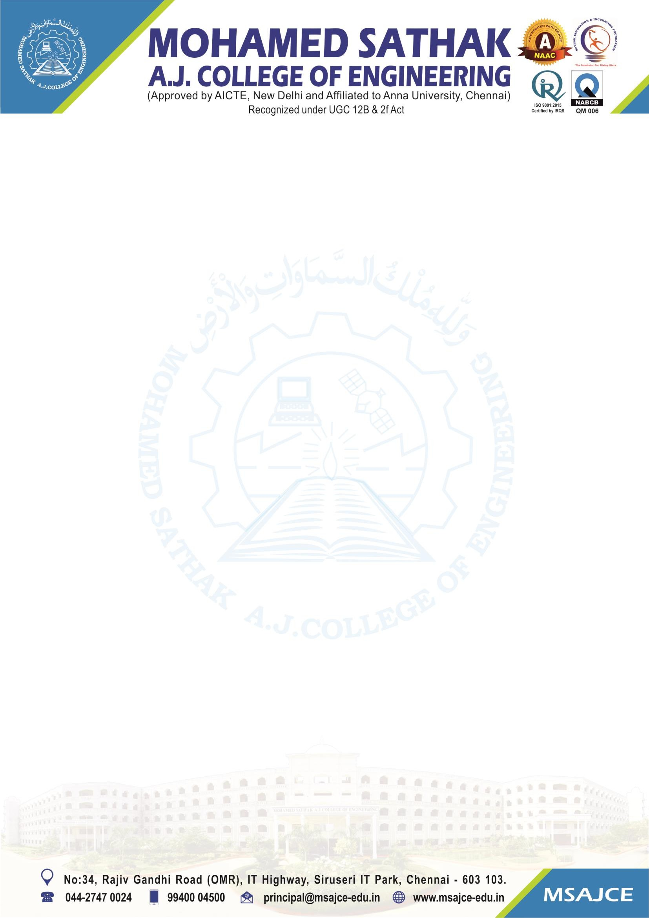
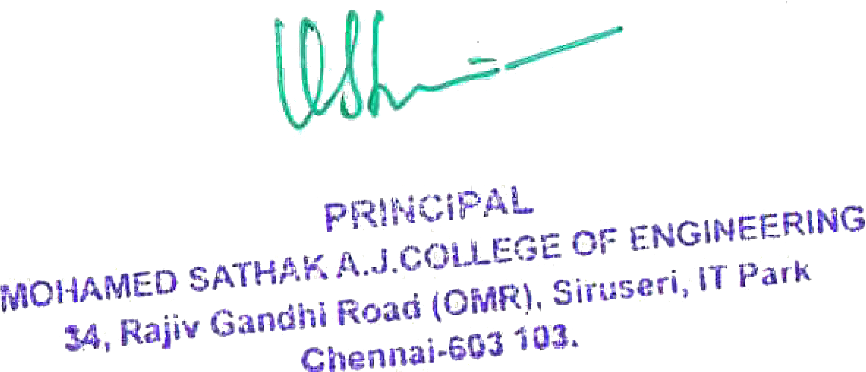

3.5.1 Number of Collaborative activities for Research, Faculty Exchange, Student Exchange/Internship during the year 2022-2023.

Note: The supporting documents for this metric exceed the upload limit of 6 Mb. Hence the documents are made available in HEI website and links for the metric is given below.

Metric | Parameter | Link to Relevant Documents
3.5.1 | Number of Collaborative activities for Research, Faculty Exchange, Student Exchange/Internship during the year 2022-2023. | View File

