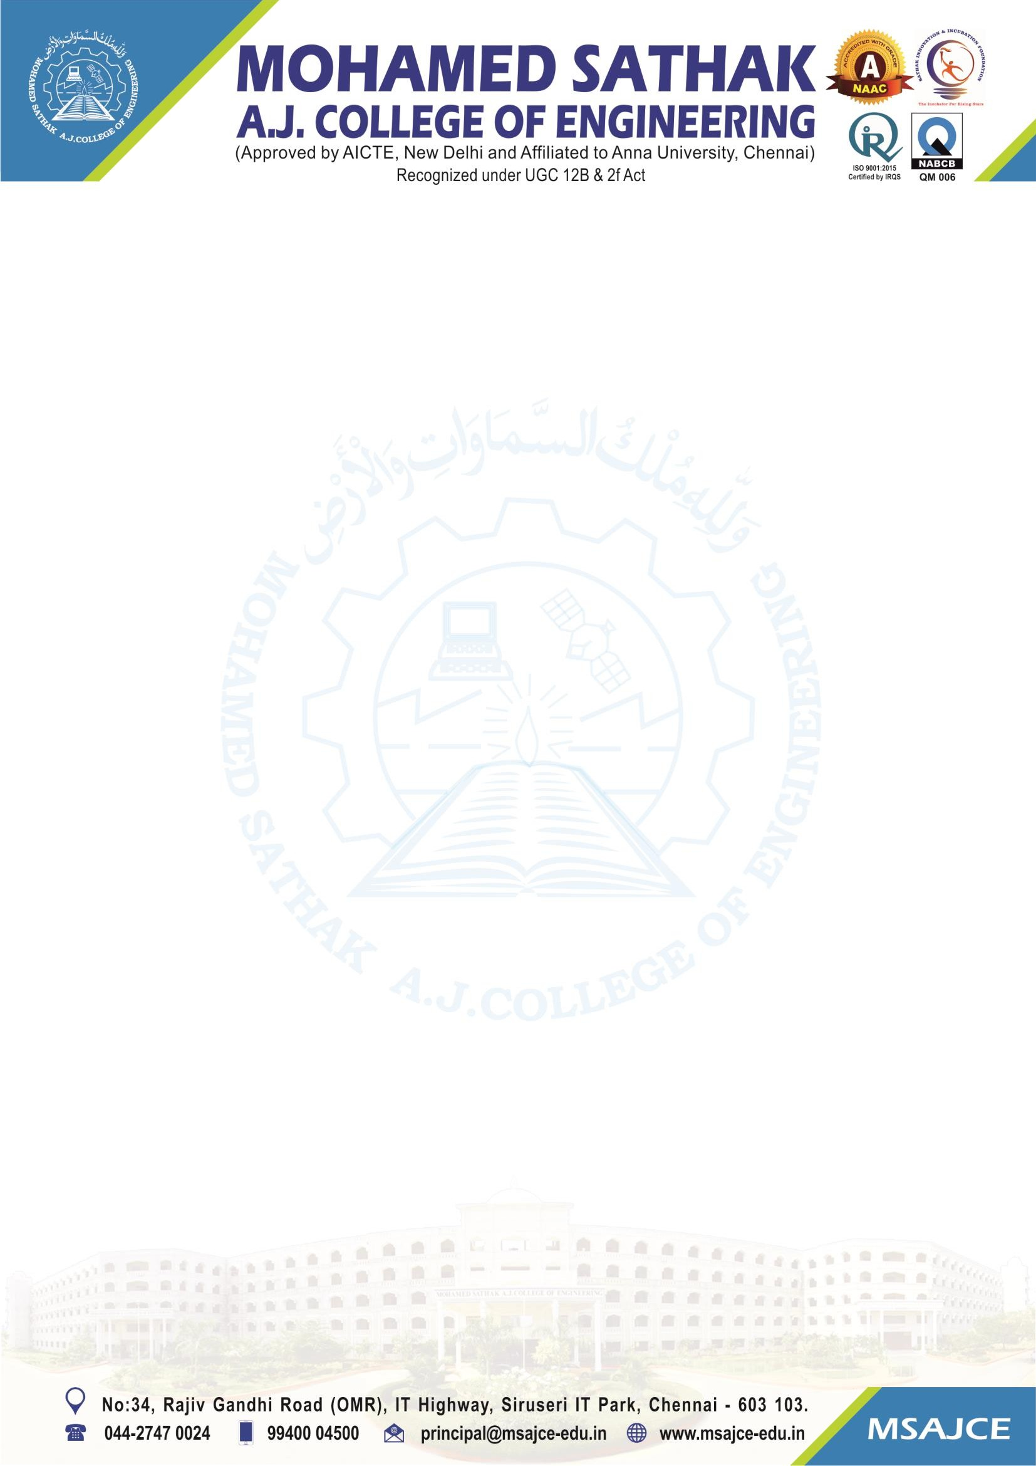
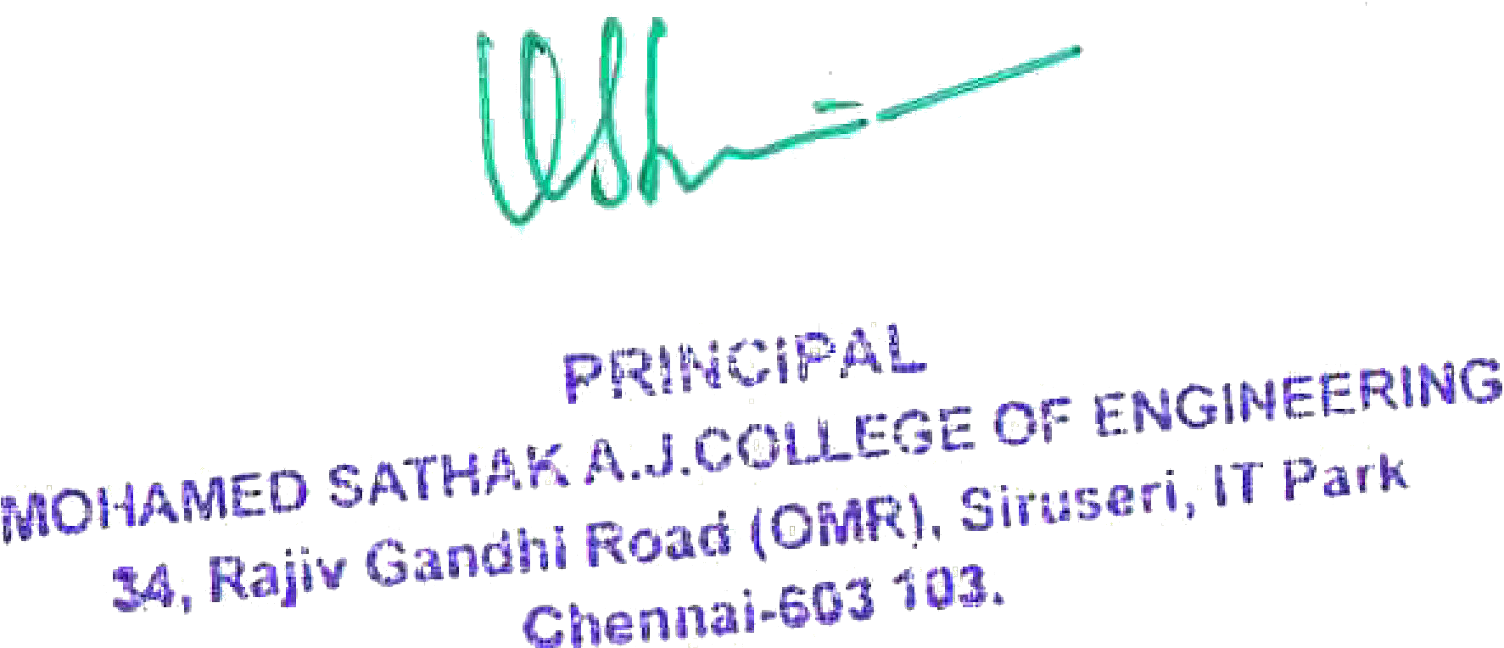

2.6.1: Programme and course outcomes for all Programmes offered by the institution are stated displayed on website and communicated to teachers and students

Note: The supporting documents for this metric exceed the upload limit of 6 Mb. Hence the documents are made available in HEI website and links for the metric is given below.

Metric | Parameter | Link to Relevant Documents
2.6.1 | Programme and course outcomes for all Programmes offered by the institution are stated displayed on website and communicated to teachers and students | View File

