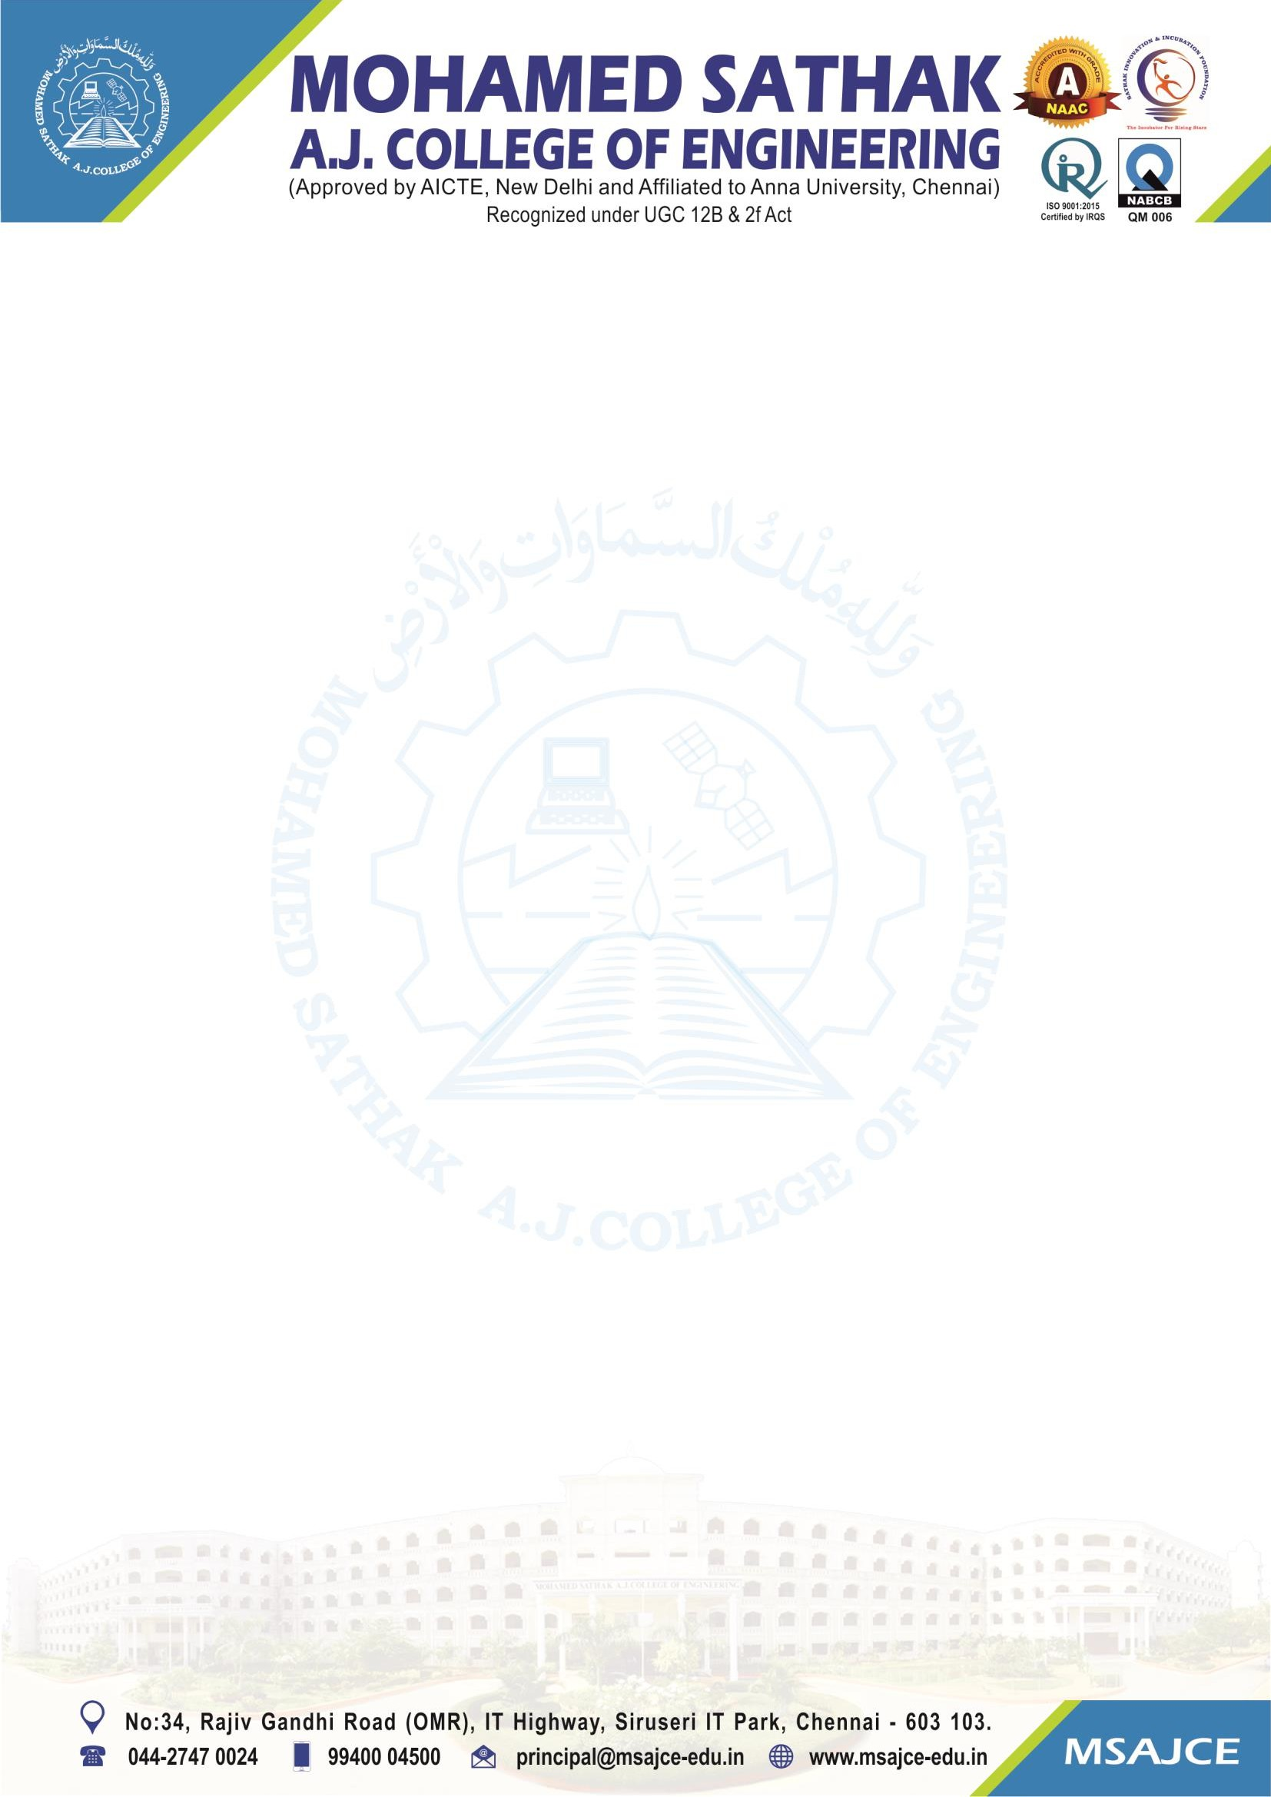
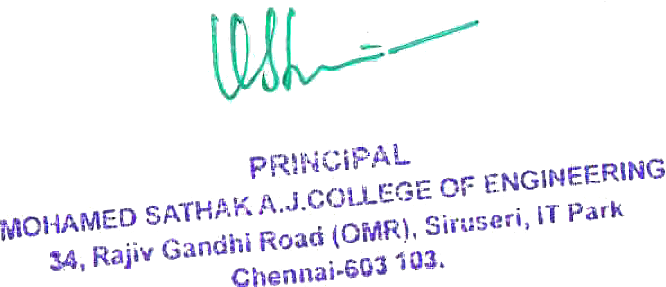

2.3.1 Students centric methods, such as experiential learning, participative learning and problem-solving methodologies are used for enhancing learning experiences

Note: The supporting documents for this metric exceed the upload limit of 6 Mb. Hence the documents are made available in HEI website and links for the metric is given below.

Metric | Parameter | Link to Relevant Documents
2.3.1 | Student’s centric methods, such as experiential learning, participative learning and problem solving methodologies are used for enhancing learning experiences | View File

