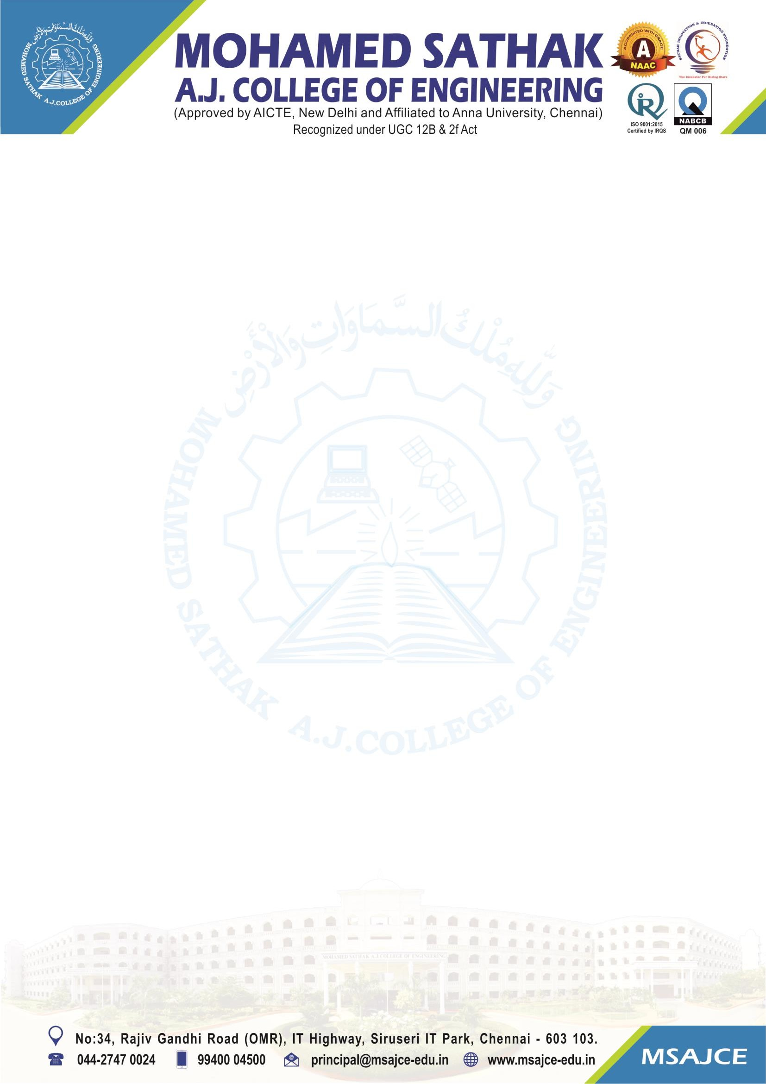
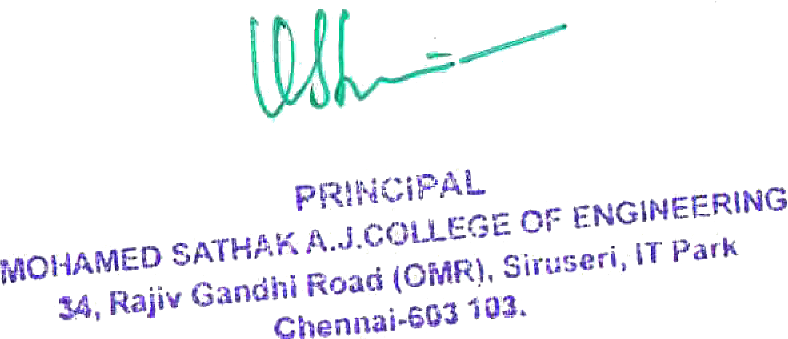

1.4.2 Feedback process of the Institution

Note: The supporting documents for this metric exceed the upload limit of 6 Mb. Hence the documents are made available in HEI website and links for the metric is given below.

Metric | Parameter | Link to Relevant Documents
1.4.2 | Feedback process of the Institution | View File

