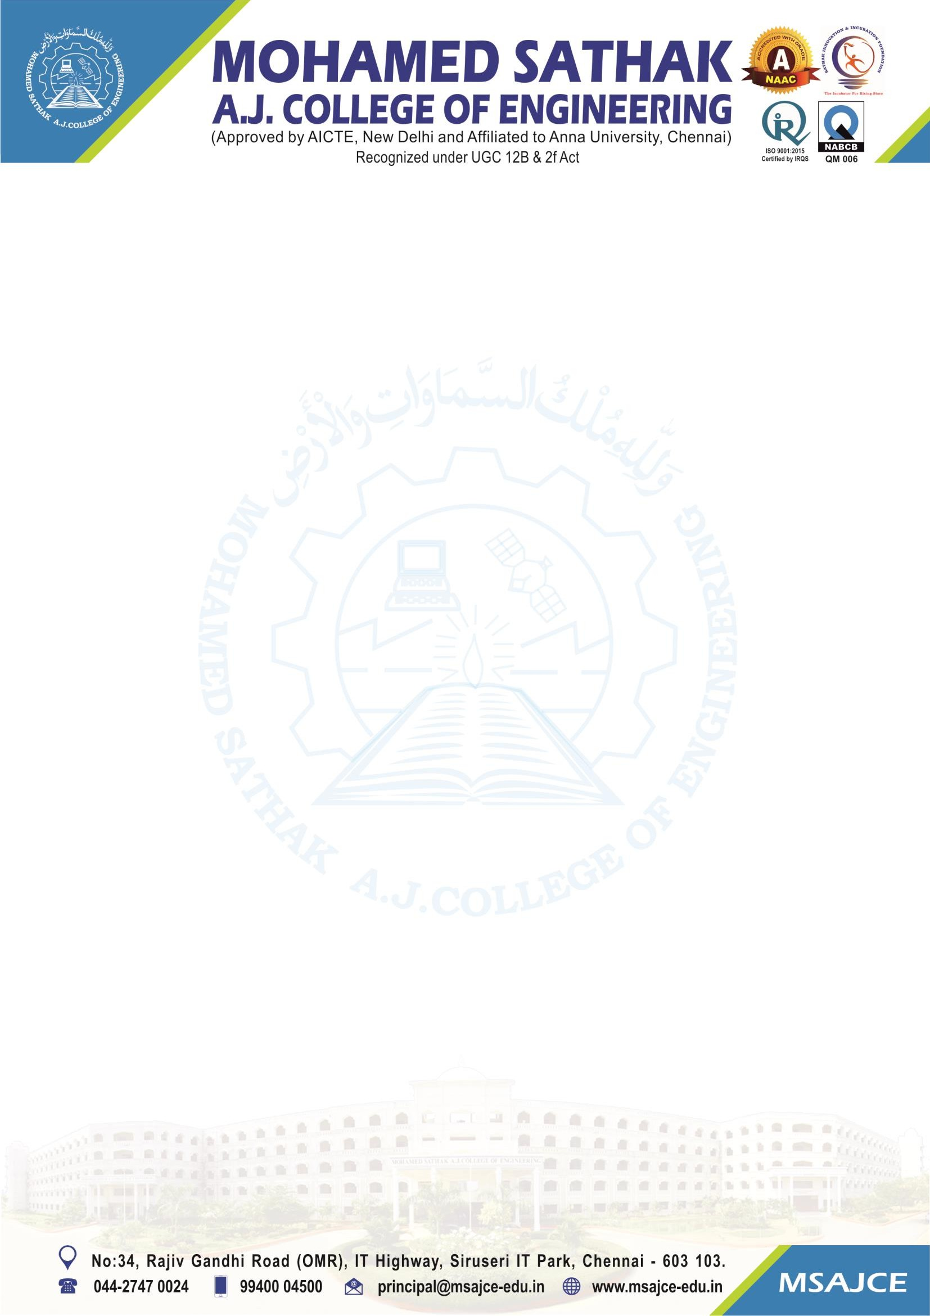

1.3.3 Number of students undertaking project work/field work/internships

To whomsoever it may concern
This is to certify that the number of students undertaking project work/ filed work/ internships is 282 for the AY 2022-2023

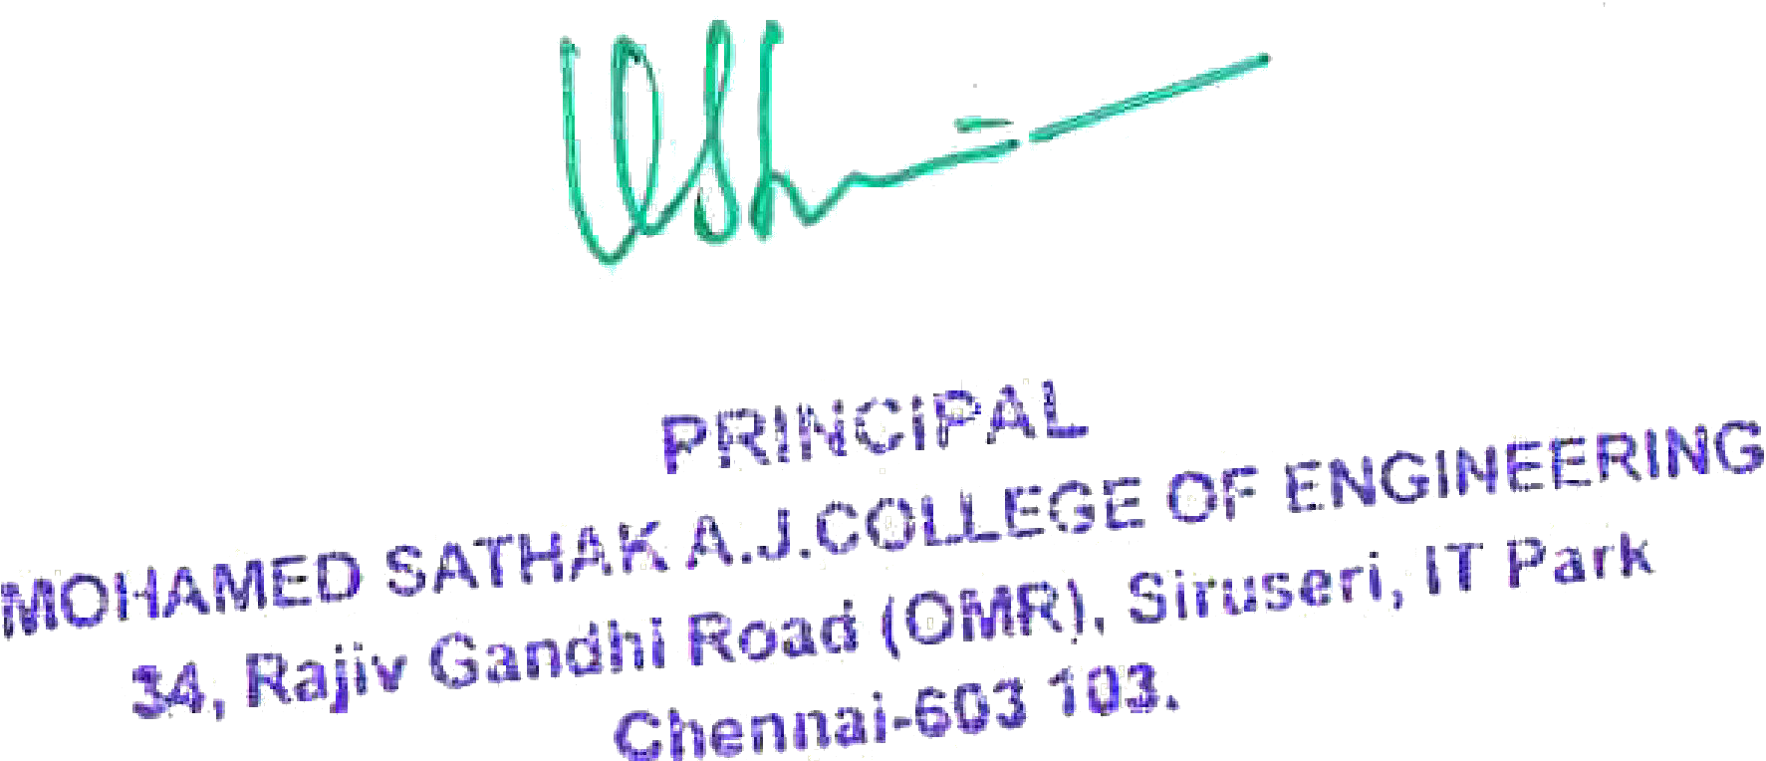

7

1.3.3 Number of students undertaking project work/field work/internships (2022-23)

S.No | Programme Name | Number of Students Undertaking Project Work/ Fieldwork/ Internship | Link to the Relevant Document
1 | Civil Engineering | 11 | View File
2 | Computer Science & Engineering | 56 | View File
3 | Electrical and Electronics Engineering | 14 | View File
4 | Electronics and Communication Engineering | 25 | View File
5 | Mechanical Engineering | 98 | View File
6 | Information Technology | 30 | View File
7 | Science and Humanities | 48 | View File

