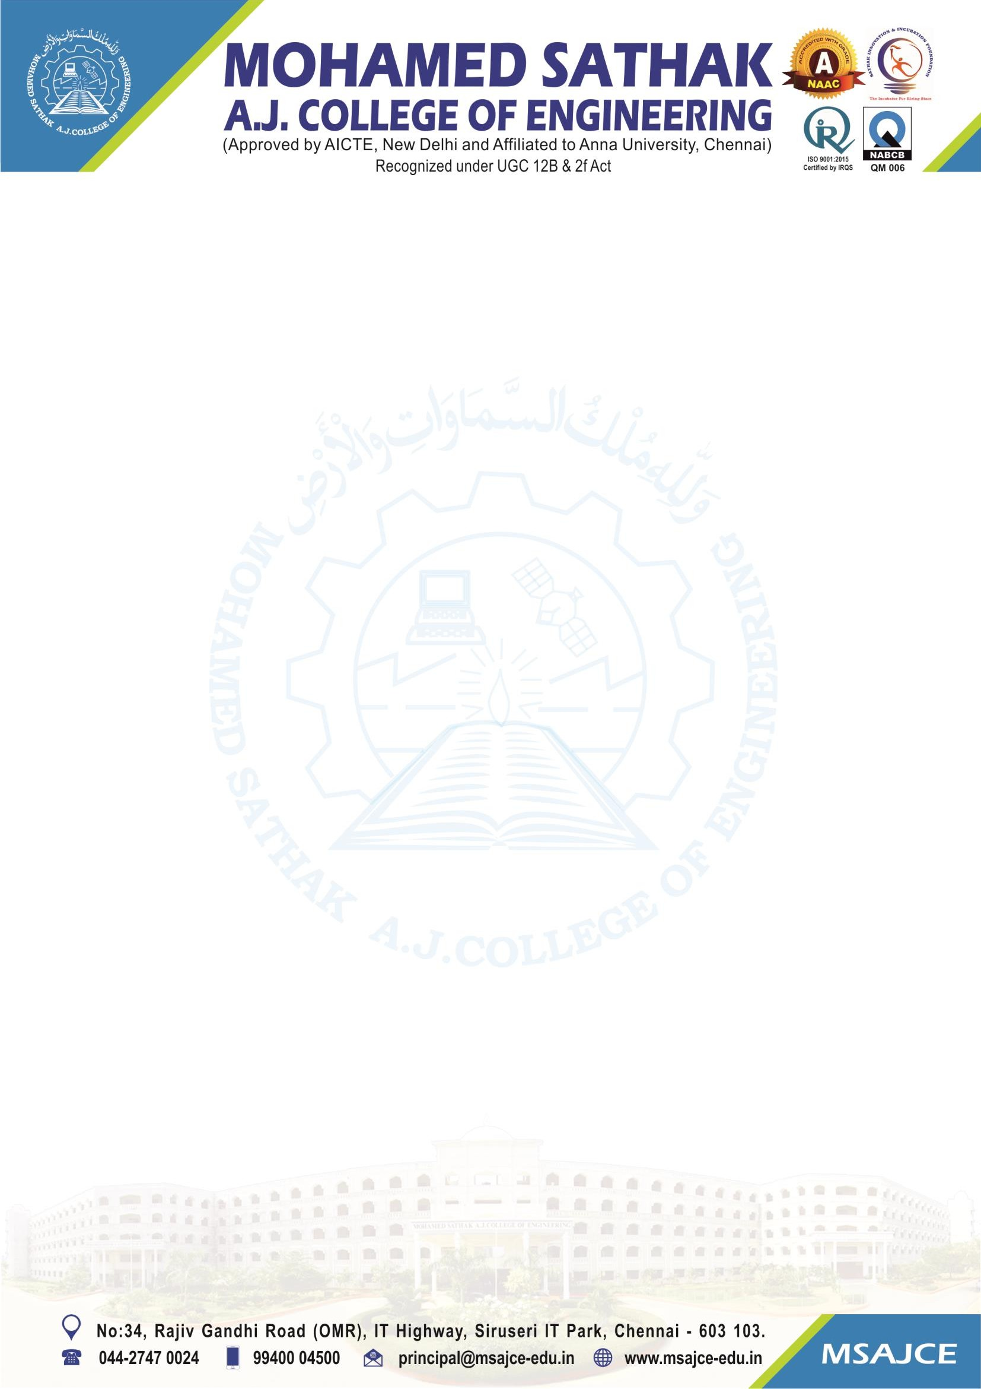
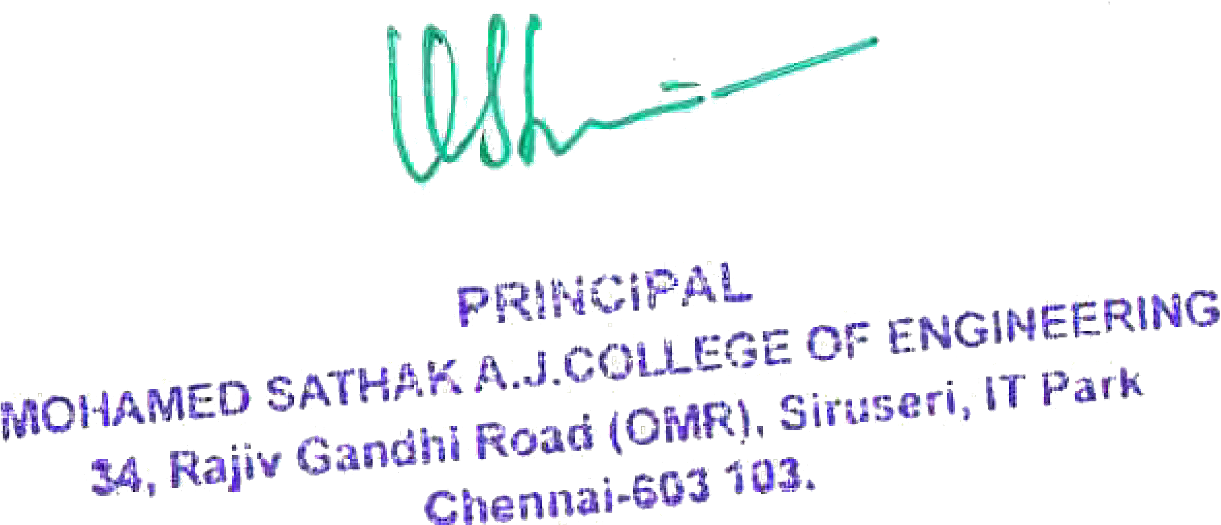

1.3.3: Number of students undertaking project work/filed work/internships

Note: The supporting documents for this metric exceed the upload limit of 6 Mb. Hence the documents are made available in HEI website and links for the metric is given below.

Metric | Parameter | Link to Relevant Documents
1.3.3 | Number of students undertaking project work/filed work/internships | View File

