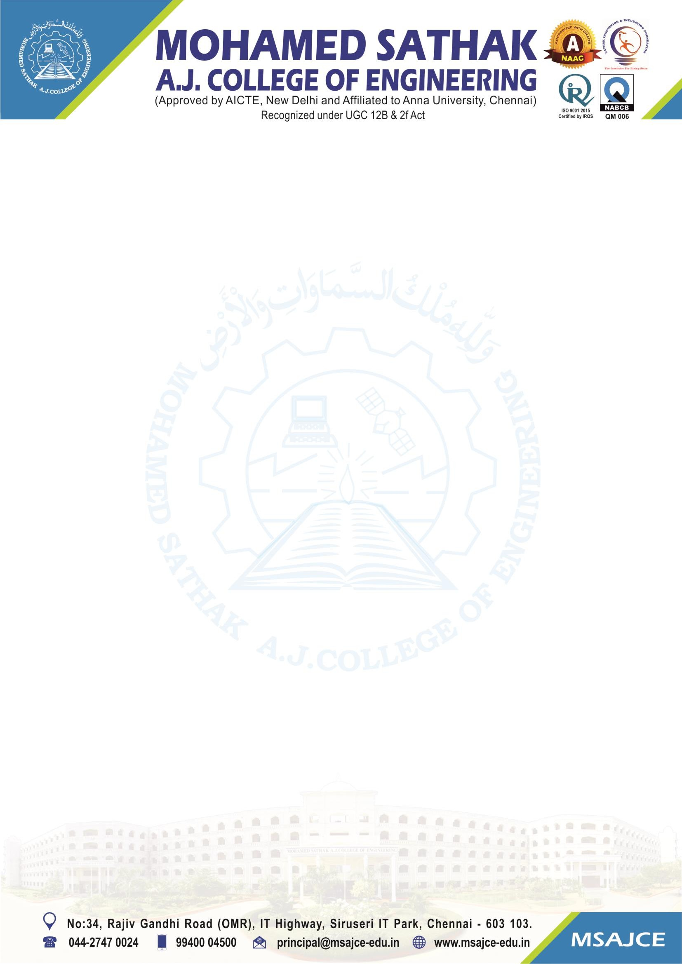
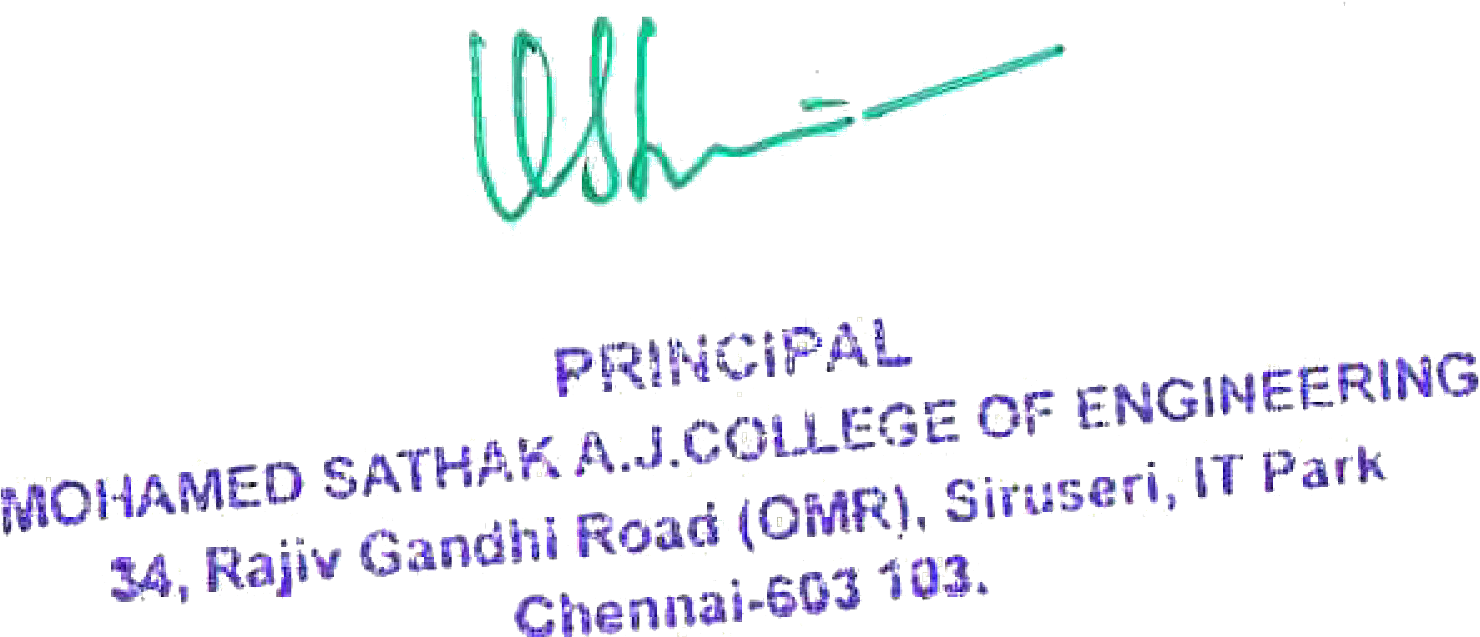

1.3.2 Number of courses that include experiential learning through project work/filed work/internship during the year

To whomsoever it may concern
This is to certify that the Number of courses that include experiential learning through project work/field work/internship is 73 for the AY 2022-2023

7

1.3.3 Number of students undertaking project work/field work/internships (2022-23)

S.No | Programme Name | Number of courses that include experiential  learning through project work/field work/internship | Link to the Relevant Document
1 | Civil Engineering | 11 | View File
2 | Computer Science & Engineering | 12 | View File
3 | Electrical and Electronics Engineering | 10 | View File
4 | Electronics and Communication Engineering | 8 | View File
5 | Mechanical Engineering | 22 | View File
6 | Information Technology | 9 | View File
7 | Science and Humanities | 1 | View File

