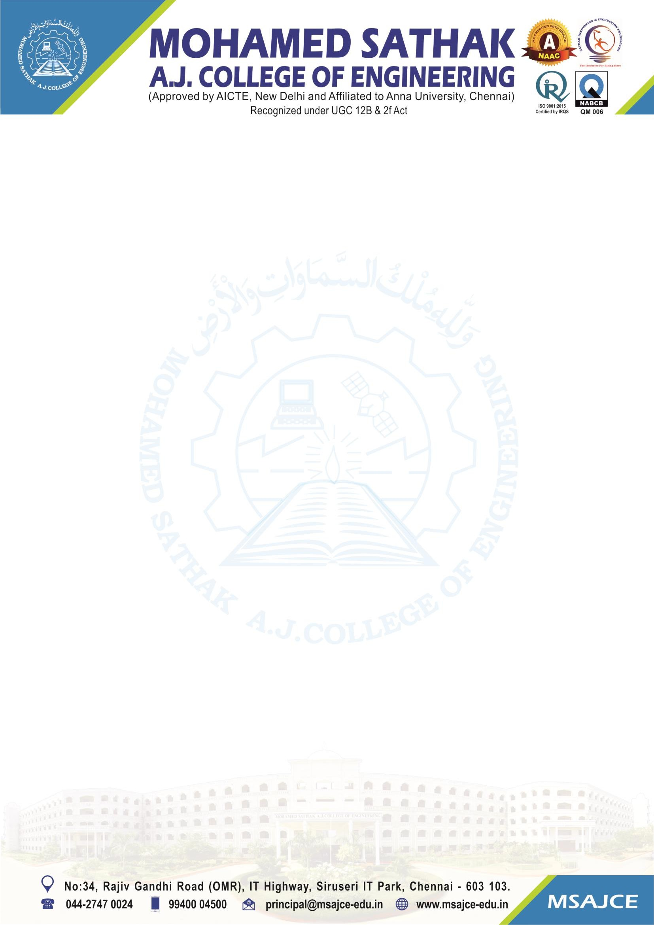
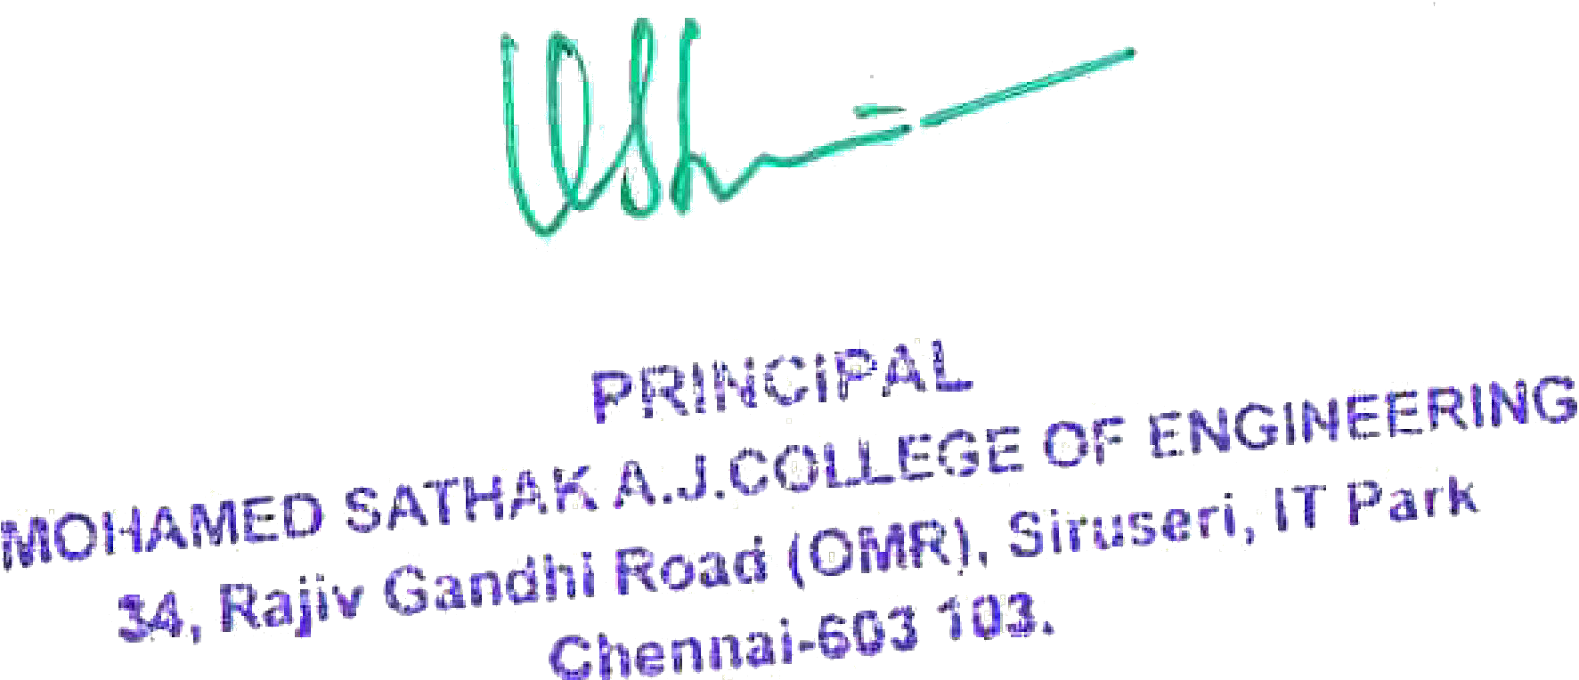

1.3.2.: Number of courses that include experimental learning through project work/filed work/internship during the year

Note: The supporting documents for this metric exceed the upload limit of 6 Mb. Hence the documents are made available in HEI website and links for the metric is given below.

Metric | Parameter | Link to Relevant Documents
1.3.2 | Number of courses that include experimental learning through project work/filed work/internship during the year | View File

