1.2.1 Percentage of Programmes in which Choice Based Credit System (CBCS)/ elective course system has been implemented.
Programme Code | Programme name | Year of Introduction | Status of implementation of CBCS / elective course system (Yes/No) | Year of implementation of CBCS / elective course system
103 | B.E - Civil Engineering | 2007 | Yes | 2017
104 | B.E - Computer Science and Engineering | 2001 | Yes | 2017
105 | B.E - Electrical and Electronics Engineering | 2005 | Yes | 2017
106 | B.E - Electronics and Communication Engineering | 2001 | Yes | 2017
114 | B.E - Mechanical Engineering | 2005 | Yes | 2017
205 | B.Tech - Information Technology | 2001 | Yes | 2017
243 | B.Tech - Artificial Intelligence and Data Science | 2022 | Yes | 2017
244 | B.Tech - Computer Science & Business Systems | 2022 | Yes | 2017
405 | M.E - Computer Science and Engineering | 2013 | Yes | 2017
413 | M.E - Structural Engineering | 2014 | Yes | 2017

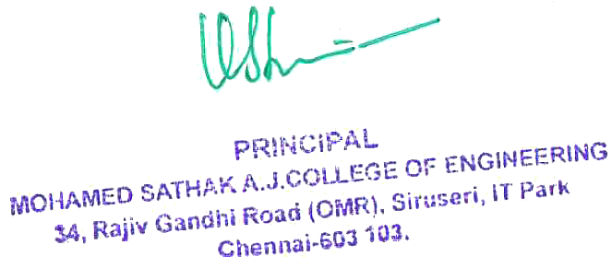

1.2.1 Percentage of Programmes in which Choice Based Credit System (CBCS)/ elective course system has been implemented.
Metric | Parameter | Link
1.2.1 | Percentage of Programmes in which Choice Based Credit System (CBCS)/ elective course system has been implemented. | View File

