1. 1. 3 -Teachers of the Institution participate in following activities related to curriculum development and assessment of the affiliating University and/are represented on the following academic bodies.

TO WHOMSOEVER IT MAY CONCERN
This is to certify that the number of Teachers of the Institution participated in the following activities related to curriculum development and assessment of the affiliating university during is given below.
Academic Year | Setting of Question Papers | Design and Development of Curriculum | Assessment and Evaluation Process | Total
2022 - 2023 | 03 | 10 | 39 | 52

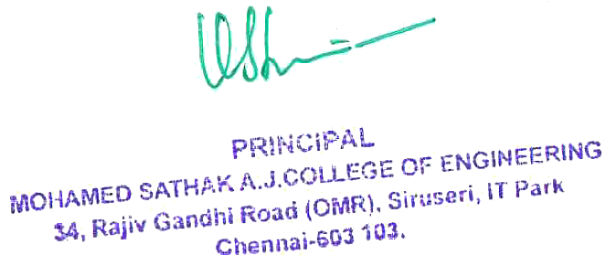

1. 1. 3 -Teachers of the Institution participate in following activities related to curriculum development and assessment of the affiliating University and/are represented on the following academic bodies.

S.No | Content | Page No.
1 | Academic Council / BoS of Affiliating University | Nil
2 | Setting of Question Papers
3 | Design and Development of Curriculum for Add on / Certificate / Diploma Courses
4 | Assessment / Evaluation Process of the Affiliating University

